REPORT z.  
PARAMETERS:empno(4)  TYPE n,  
           ename(10) TYPE c.  
AT SELECTION-SCREEN OUTPUT.  
LOOP AT SCREEN.  
IF SCREEN-NAME = 'ENAME'.  
    SCREEN-INPUT = 0.  
    MODIFY SCREEN.  
ENDIF.  
ENDLOOP.  
START-OF-SELECTION.  
WRITE :/ 'Ename is :', ename.  
WRITE :/ 'Empno is :', empno.

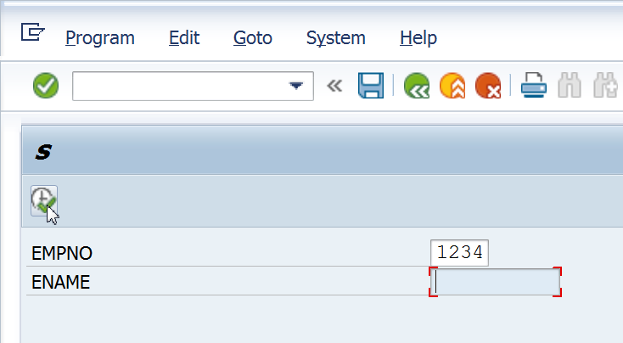

No Data Entry is allowed in Ename.

If the above is changed to SCREEN-INPUT = 1, data entry will be allowed, and a screen as shown below, will be seen.

